Using Modified Neural Stem Cells to Inhibit Breast Cancer Brain Metastasis
The great success of the humanized monoclonal antibody Herceptin™ (trastuzumab, anti-HER2 ab) in the treatment of systemic metastatic disease [1] has boosted survival in many patients suffering from human epidermal growth factor receptor 2 (HER2)-positive breast cancer. However, longer survival time and the inability of the antibody to cross the blood-brain-barrier (BBB) have led to an increase in the number of patients presenting with breast cancer brain metastases (BCBM).
To meet this therapeutic need, researchers from the laboratory of Maciej Lesniak (The University of Chicago Pritzker School of Medicine, USA) developed an FDA-approved neural stem cell (NSC) line (IND14041) which can cross the BBB, home to tumor sites [2, 3], and deliver the anti-HER2 antibody directly to metastatic breast cancer cells in vivo [4]. In their new study, the group used intracranial transplantation studies to show that their newly modified NSCs improved survival in mice and may represent an important new strategy in the treatment of BCBM [5].
The authors utilized lentiviral transduction and selection to create a stable modified NSC line which released and assembled much higher amounts of the anti-HER2 antibody as compared to their previous report which employed adenoviruses to produce the antibody [4]. These newly modified NSCs specifically bound HER2-overexpressing breast cancer cell lines in vitro, and significantly reduced cell proliferation via the inhibition of HER2-mediated activation of PI3K-Akt signaling.
To assess the in vivo effectiveness of the modified NSCs in a preclinical mouse model of BCBM, the authors intracranially seeded human BT474Br cells (HER2 overexpressing breast cancer cells that metastasize to the brain) and treated the resulting tumors by adding the modified NSCs at the tumor site. They found that the modified NSCs targeted and delivered the anti-HER2Ab to BT474Br cells, and, excitingly, further experiments demonstrated that this ability afforded mice a survival advantage of around 30 days as compared to mice with no treatment or mice receiving unmodified NSCs (See figure).
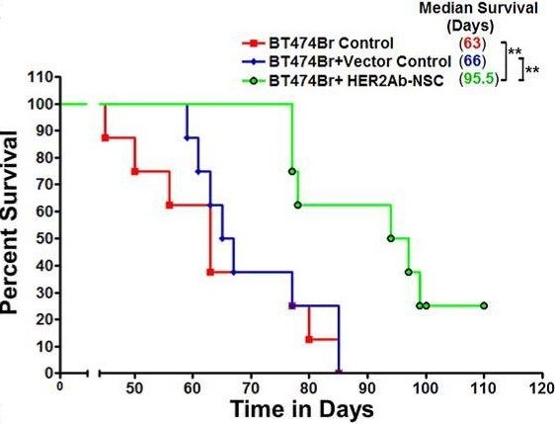
In essence, the authors have generated a biological means to produce a localized anti-tumor therapy which inhibits cell growth while minimizing unwanted side effects, such as the cardiotoxicity normally associated with intravenous Herceptin treatment [6]. While this will be important to breast cancer sufferers and relevant to brain metastases, HER2 over-expression occurs in other tumors and metastases, including epithelial malignancies and lung and bone metastases from breast cancer. Therefore, further preclinical and clinical investigations using modified NSCs need not restrict themselves to the brain; indeed this mode of treatment may be relevant to a wide range of cancer patients.
Discussion Points
- Will modified NSCs injected into the bloodstream be as effective as intracranial delivery?
- What other problems may be encountered using systemic application?
- Will other HER2-overexpressing tumors/metastases also be effectively targetted?
- Can other therapies be delivered in this manner?
References
- Slamon DJ, Leyland-Jones B, Shak S, et al. Use of chemotherapy plus a monoclonal antibody against HER2 for metastatic breast cancer that overexpresses HER2. N Engl J Med 2001;344:783-792.
- Aboody KS, Brown A, Rainov NG, et al. Neural stem cells display extensive tropism for pathology in adult brain: evidence from intracranial gliomas. Proc Natl Acad Sci U S A 2000;97:12846-12851.
- Kim JH, Lee JE, Kim SU, et al. Stereological analysis on migration of human neural stem cells in the brain of rats bearing glioma. Neurosurgery 2010;66:333-342; discussion 342.
- Frank RT, Edmiston M, Kendall SE, et al. Neural stem cells as a novel platform for tumor-specific delivery of therapeutic antibodies. PLoS One 2009;4:e8314.
- Kanojia D, Balyasnikova IV, Morshed RA, et al. Neural Stem Cells Secreting Anti-HER2 Antibody Improve Survival in a Preclinical Model of HER2 Overexpressing Breast Cancer Brain Metastases. Stem Cells 2015;33:2985-2994.
- Bria E, Cuppone F, Fornier M, et al. Cardiotoxicity and incidence of brain metastases after adjuvant trastuzumab for early breast cancer: the dark side of the moon? A meta-analysis of the randomized trials. Breast Cancer Res Treat 2008;109:231-239.

